


Boeing Autonomous

Project Management Report

Elise Chantegros, Budget Liaison
Selina Cozens, Project Manager
Jacob Keeland, Brakes & Manufacturing
Marek Lemieux, CAD Lead
Desirae Mangum, Fundraising Lead
Natasa Peric, Capstone Lead
Lily Quintanar, Intra-group Communications



Spring 2026

Sponsors/Technical Mentors: Donald Guzman and Connor Nolan
Instructor: Professor David Willy
Group Number: F25toSp26_02
Introduction
Purpose
The purpose of the project management report is to carefully reflect on the team’s strengths and weaknesses throughout the past semester. This report serves to identify areas that the team excelled in and other areas needing improvement to outline an effective plan for the current Spring semester. Because it is the last semester for this capstone, the team holds the united goal of finishing off with a satisfactory mechanism for the go kart and corresponding results. Through the method of highlighting key lessons and noting important corrections, the team has outlined its future design efforts through detailed purchasing requirements, manufacturing standards, and organized schedules to set a clear foundation for the second semester of the capstone project. Hence, this report offers the method that the team plans to maintain evenly distributed work and expectations aligned for both the course and the clients for a successful semester.
Reflection
Project Management Achievements
The team reached key milestones throughout the semester through solid coordination and collaboration in a timely manner. Outlined in this section are some of the most notable patterns found in the team’s capabilities of delivering quality work and progress.
- Strong Coordination: Selina was very successful in reminding the team of internal deadlines, upcoming deliverables, and important information from Professor Willy or the Boeing clients. She also consistently followed up with missing details on timecards, assignments, and information from the rubric. In doing so, Selina led the team in a successful direction by consolidating submissions and making sure that all requirements were fulfilled by the team to the best of their abilities.
- Reliability: The team displayed a reliable sense of execution for tight deadlines and high priority items. This characteristic was largely displayed in the report for Prototype 2 and the second updated report of the semester. Moreover, details for the BOM charts were completed on time and received good remarks.
- Editing and Submission: Selina was initially in charge of naming and merging files for the team and affiliated sub-teams. She was also appointed to submit most assignments, verifying that there was no late work. For large reports and submissions with several files, Natasa coordinated formatting, editing, and final edits to make sure that each deliverable was ready to be submitted. She also assisted in making sure that each of the most updated version was submitted for each deliverable promptly.
- Effective Collaboration: The team excelled in coordinating and sharing information between all members to make sure that everyone had access to all files and folders. Shared documents through Google and Microsoft were key in making sure all members could access all material, and any issues were quickly resolved through team group chats and virtual meetings.
- Consistent Communication: The team has maintained consistent communication through their group chat on Microsoft Teams and staff meetings, in which all questions have been regularly addressed. Information has been effectively delivered during staff meetings, and group meetings outside of class have kept a high attendance rate.
- Sub-team Leaders: All sub-team leaders have shown considerable dedication to account for their responsibilities and follow through with their progress.
  - The brakes were not reinstalled correctly, and the brakes' sub-team took the responsibility upon themselves to make sure that it would not be an issue during the Spring semester.
  - Sub-team leaders have managed conflict between other sub-teams by steering the conversation towards a solution. During staff meetings and conversations in the group chat, there have been discrepancies on due dates and submission requirements for reports, in which sub-team leaders have displayed their sense of leadership by maintaining a positive attitude and working to help one another.
- Internal Deadlines: The team set internal deadlines early with clear expectations of requirements from all team members. This sense of clarity through specified times and dates for submissions allowed all members to plan accordingly for their portion of each deliverable. The deadlines also allowed all members to have roles to even out the overall workload and make sure that assignments could be submitted on time.
Room for Improvements
Over the course of the past semester, certain recurring patterns surfaced amongst the team’s sense of preparedness and abilities to maintain internal expectations. To prevent such last-minute pressure this semester, this section outlines the specific setbacks the team experienced during the Fall semester and how they affected overall progress.
- Overdue Internal Deadlines: Internal deadlines were set by team lead Selina, but some members continued to work past the time at which a deliverable should have been completed.
  - Sub-teams completed their work for presentations and demonstrations, but these results were reported within hours before the posted due date, which caused an issue between sub-teams tying together their work and displaying how each sub-team effectively can work with one another. For example, all sub-teams had a demonstration for prototype 2, but there was a clear disconnection between sub-teams in terms of where each component would connect (i.e., there was no battery) and how they would not interfere with one another (i.e., overloading voltages).
  - Reports, specifically, were often completed past the internal deadline because there were notes of inaccurate information, informal writing, poorly revised paragraphs, or missing details crucial to touch on all necessary points.
- Unpreparedness: Some team members did not attend Professor Willy’s office hours as frequently as others, in which their lack of preparedness was visible during presentations and prototypes. There were also times when some members had late questions about deliverable formats and requirements, often for an assignment due that same day.
- Time Management: Issues with time management were reported specifically for prototypes and the work time needed in the garage.
  - Because there is only one current garage supervisor (Trent Greene), difficulties arose in the second half of the Fall semester when prototypes were becoming more complex and more work needed to be done on the kart. Schedules to work in the garage changed frequently, and because both Boeing Autonomous and Formula had different capstone sessions, Boeing Autonomous would often leave early because the Formula team had to get to class, which limited progress.
- Accountability: Some members experienced issues within their sub-teams where one person did not complete or offer quality work for their part of the deliverable. This setback often resulted in having the other sub-team member work on the rest of the project at the last minute.
  - Because the brakes were not repaired until the start of the Spring semester, no members have been able to ride the go-kart without having other team members hold onto the sides to make the kart stop moving.
- Miscommunication: Especially in high-tension situations, there were issues of miscommunication for deliverables that led to poorly handled disagreements.
  - Tensions rose during Prototype 2 and Report 2 because the go-kart was still in repairs at the time of the assigned work. Prototype 2 was centered on mounting solutions rather than having any moving parts or motors, which caused some team members to grow frustrated within their sub-teams. Moreover, Report 2 was considerably longer than Report 1, in which there was more information to include than what some team members had originally anticipated.
Project Management Action Items
To be more prepared for the upcoming semester, the team has examined achievements and areas of improvement to formulate a list of necessary tasks. To ensure that past mistakes are resolved, below is a list of action items the team plans to follow to improve morale and efficiency.
These practical steps address the main gaps:
- Add a 48-72 hour checkpoints- Require a 50% draft and status update mid-week for major deliverables. Allowing for early issue resolution reduces the rush.
- Require 12-hour readiness confirmation- Sub-teams post “complete” before final cutoff. Eliminates surprises and improves accountability.
- Maintain a central requirements document- One shared sheet with formats, naming rules, and preferences, updated after feedback. Prevents repeated clarification.
- Hold weekly 30-minute prototype check-in- Log last user, issues, and next steps in a shared sheet. Improves tracking and scheduling (option: shared logging doc)
- Require escalation for outside support when blocked- If team members are stuck during a portion of the project, more action needs to be taken to reach out to outside support, whether it be the professor, the clients, or the team’s mentor.
- Weekly Meeting for Progress- Sub teams set weekly meetings to set aside time to make progress on the project. Adding that step of putting the plans in action, ensuring that there is equal participation in executing testing and assembly.
Remaining Design Efforts
To display the autonomous capabilities on the go-kart, each sub-team has remaining design efforts to fulfill for the final design of the go-kart. Divided by each sub-team, the following items must be finalized within the Spring semester.
Brakes:
- Re-Evaluate- Actuation (Spool vs lever arm); single or miniature spool for compact/low-flow design; single vs tandem spool, material (aluminum or stainless steel), and we can validate with FEA.
- Optimize all CAD designs- Apply Design for Manufacturing (DFM) principles, including appropriate draft angles, fillets for stress reduction, uniform wall thickness, etc., which can be done via topology optimization or strategic ribbing.
Steering:
- Optimize safety features- Design housing for gears; through-pin failsafe
- Material Selection- Finalize material selection for gears and obtain gears
- Design of Gear Box- CAD model, use cardboard to check sizing, manufacture the box using sheet metal
- Final Calculations- Update calculations to match current design state
- Obtain through pin- After final calculations, obtain the proper size pin and install
- Redesign of the Motor Box- Redesigning and reprinting the motor box to allow the motor to be secured to the box with bolts and nuts instead of zip ties. Depending on the size of the gears purchased, the placement of the clamp or the size of the box may be adjusted.
Throttle:
- CAD designs of the full assembly and corresponding sub-assemblies must be finalized to provide a clear set of instructions and information regarding the safety and construction of the throttle mechanism for the autonomous go-kart.
  - Add a third point of contact for the stepper mounting mechanism
- Materials used for the mounts must be optimized as original encasings used a combination of metal (stainless steel) or 3D-printed (PLA) materials that may not last because of highly anticipated strain and chafing over time.
  - Research and redefine materials using a metal 3D printer.
- Calculations must be finalized through testing results (i.e., vibration patterns and results when the go-kart is moving in dirt) to ensure corresponding results for a safe and effective autonomous system.
Gantt Chart
Using the tentative schedule and internal expectations, the Boeing Autonomous team collaborated to organize the team's Gantt chart. This section defines the major deadlines the team must meet to move forward.
- Engineering Calculations – Due @ 11:59 pm on 1/22/26
- Self-Learning or Individual Analysis - Due @ 11:59 pm on 1/29/26
- Hardware Update 33+% - Due @ 11:59 pm on 2/2/26
  - Design Efforts- 100%
  - Purchasing Plan- 67+% purchase, 33+% on hand
  - Manufacturing Plan- 33+% Build
  - Demonstration- 33+% of project
A cropped version of the Gantt chart can be seen in Table 1. The full Gantt chart is in the Appendix.

Table 1: Gantt Chart
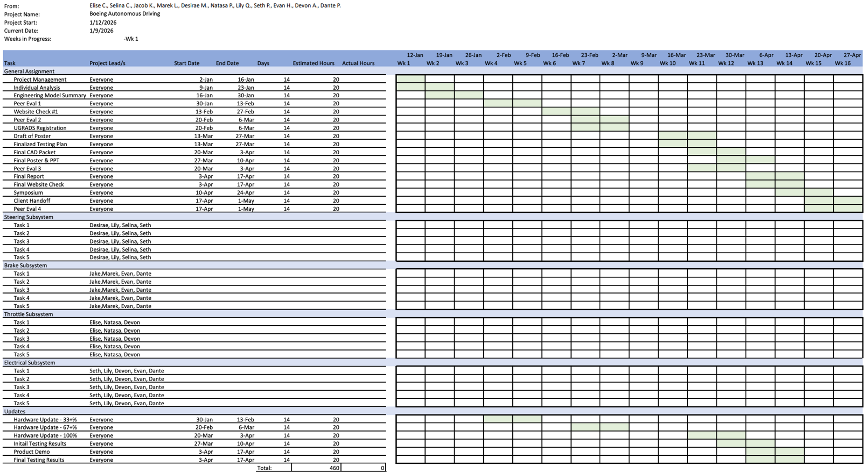
Top Level Finances
The top-level finances provide a summarized view of the project’s overall budget, including total income, total expenses, and remaining funds. This overview allows the team to track spending as the project nears completion and to identify whether additional fundraising is required to remain within budget.
The income table lists all funding sources, including the initial Boeing donation and funds raised through GoFundMe, Chipotle, and Raising Cane’s. These are totaled to show the project’s overall income. The expenses table summarizes major spending categories, including miscellaneous expenses (such as the go-kart), tools, and sub team costs for brakes, steering, throttle, and electrical. The final summary table compares total income to total expenses to calculate remaining funds.
Table 2 : Incomes Table 3: Expenses
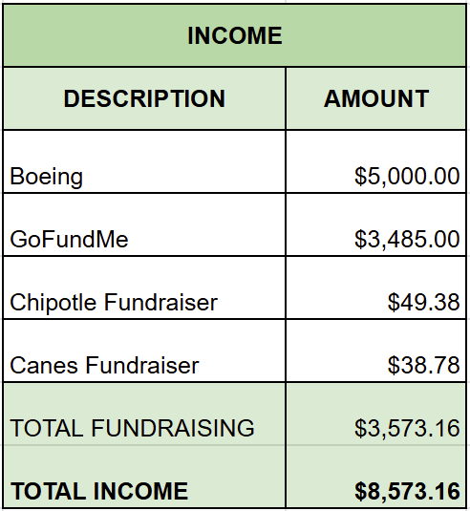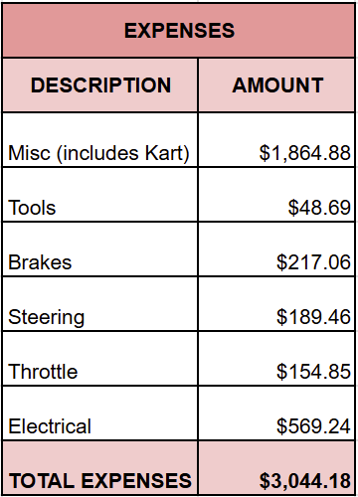

Table 4: Financial Summary
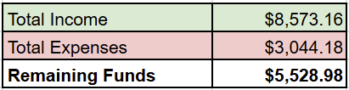
Purchasing Plan
The purchasing plan is based on the project’s most up-to-date Bill of Materials (BoM) and outlines how all required components are/will be acquired. Each BoM entry includes the part cost, a make/buy designation indicating whether the part will be made, purchased, or donated, the vendor, and the expected lead time.
The part status column is used to monitor procurement progress throughout the project. Parts marked as not started represent anticipated purchases, on order indicate items have been purchased but not yet received, being manufactured refers to parts currently in production, in-house indicates items that have been received, and assembled indicates components that have been integrated into the system. This plan ensures organized and efficient management of all purchasing activities.

Current Bill of Materials (BoM)
- Brakes
The BOM below reflects prototype 1’s configuration, supporting parallel prototyping of both a cable-driven mechanical disc brake actuated by a single high-torque RC servo motor and a hydraulic disc brake system. The complete list of purchased items is listed in the brakes BOM, including the High Torque DC Servo, mechanical brake caliper, and Master Cylinder, which are critical to the progression of the brakes system. The team plans to purchase an Arduino Nano, and they must also recreate the custom spool and motor enclosure. These additional components will be important in making sure all components can effectively communicate with one another when the kart is in motion.

Table 5: Current Brakes Bill of Materials
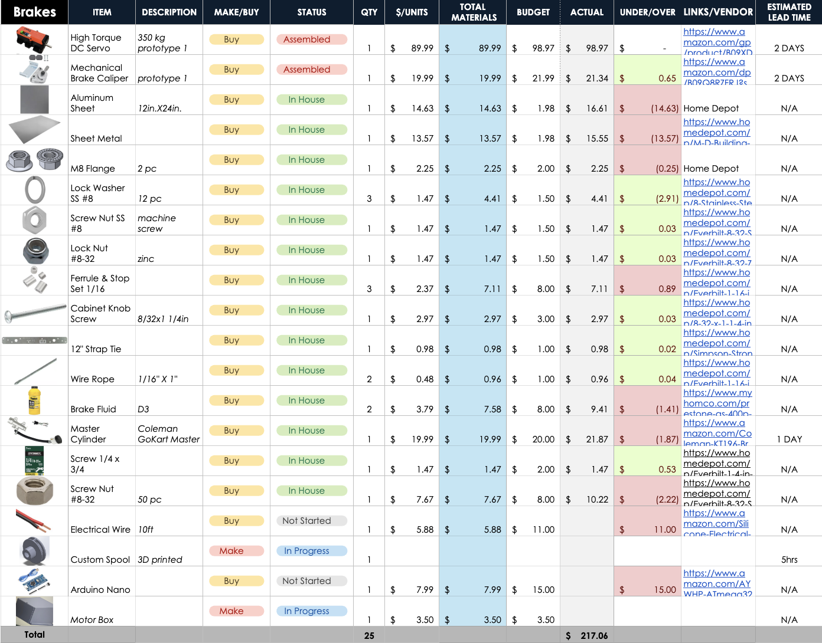

- Steering
For the current steering prototype plan, the team assembled their BoM with a combination of past purchases, along with future pending purchases they plan to make for their subfunction. Since last semester, the team purchased a motor, zip ties, an Arduino Nano, and wires. For the upcoming spring semester, the steering sub team will be focused on the gear train and gearbox portions of the subfunction. This will require the steering sub team to purchase metal gears, Loctite Blue for stabilization, aluminum plates for forming the gearbox, and fasteners to keep the parts intact (through pin, bolts, and nuts) as shown in Table 6 below. According to the BoM, the steering sub-team is staying below its assigned budget.
Table 6: Current Steering Bill of Materials
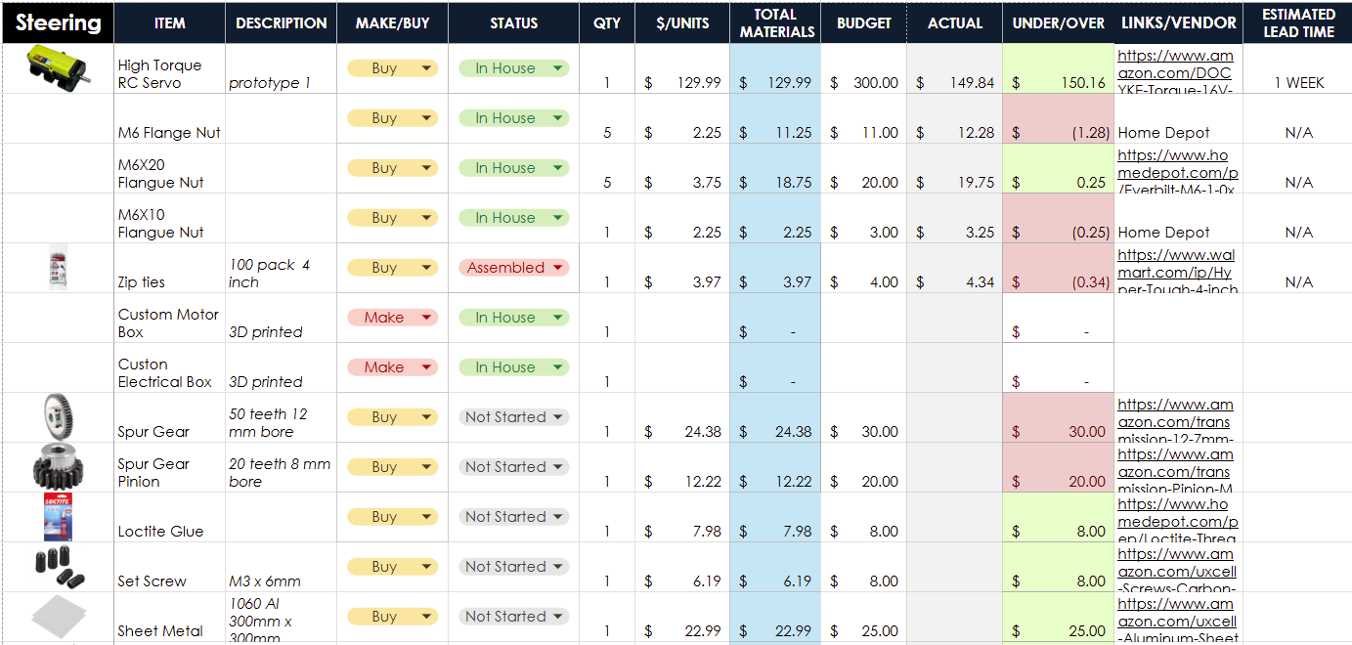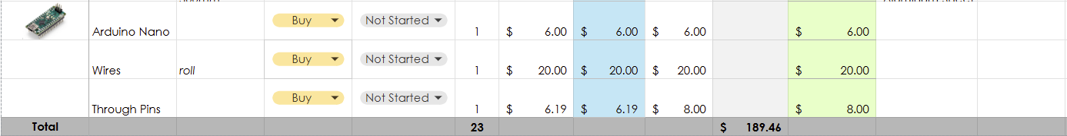

- Throttle
The Bill of Materials (BoM) for the throttle incorporates the existing purchases made for the throttle design, as well as anticipated purchases. Additional planned items and work include making protective enclosures for the encoder at the pedal and for the stepper motor and encoder located at the rear. The team will also finalize all wire connections and get a breadboard, electrical wiring, and other necessary electrical components to support system integration and testing. Furthermore, the current encoder at the pedal will be replaced with a potentiometer to provide more accurate and reliable position sensing.
Table 7: Current Throttle Bill of Materials
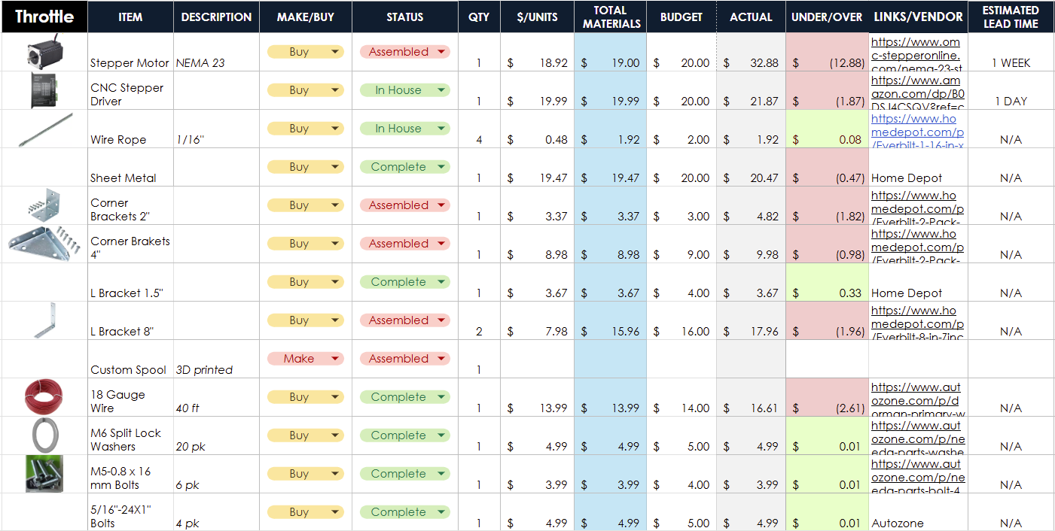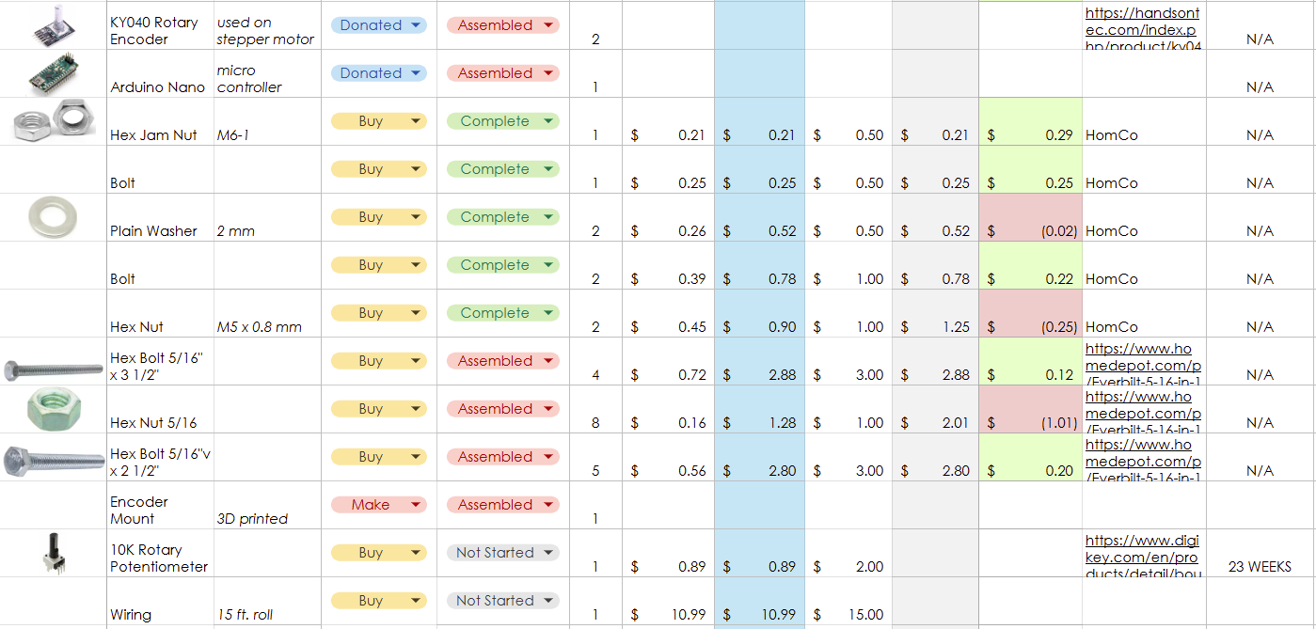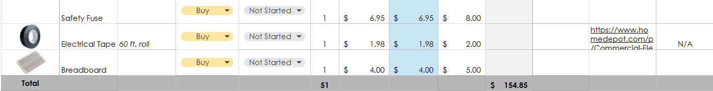

- Electrical
Table 8: Current Electrical Bill of Materials
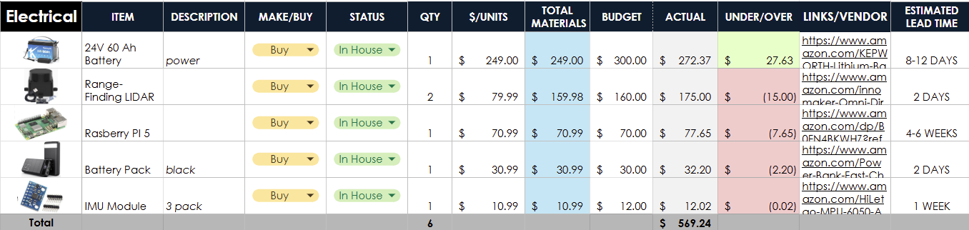
Manufacturing Plan
In this semester, the team has identified that not all components of their respected sub teams can be bought. To plan ahead, each sub team has analyzed what parts need to be done to complete their subfunctions. This section will go into detail about who will make the part, how long it will take to manufacture, the material, and where it will be made.
Brakes
- Stainless Steel Wire- his wire was crimped to the lever arm of the brake caliper and the spool. This will allow the motor to spin the spool with the wire pulling the brake. Marek was tasked with manufacturing the configuration, and it is already complete. The current wire pull design may be altered by February 6th to ensure enough time for testing. If the wire is altered, it will be made of a strong material such as steel to avoid failure.
- Base Plate- The base plate is a .3-inch-thick sheet of stainless steel that was manufactured to hold the motor to the rear of the cart. Jacob was tasked with manufacturing this part, and it is already completed and fixed to the cart frame. There is no current plan to replace the base plate, as it should bear the loads needed for the project.
- Spool- The spool is a 27.5mm diameter hold that joins the motor to the stainless-steel wire. The current iteration of it was manufactured through 3D printing by Seth, in future iterations, it will be machined out of aluminum or steel. There is also the possibility of increasing or decreasing the size of the spool to decrease the load on the motor or increase the speed of the caliper arm. It is currently anticipated that the spool will be re-manufactured by February 6^{th,} and further stress testing will ensue.
- Motor Housing- The motor housing is a design for protecting the motor as well as containing the electronics inside. It has not been manufactured, but it will be first manufactured through 3D printing, as it will not bear any significant loads.
- Brake Caliper Mount- The current brake caliper mount is made of stainless-steel L brackets, which were manufactured by Jacob and Marek. It is a simple but crucial mount designed to hold the brake caliper steady. There are plans to hopefully make a more structured mount before February 6th. The newest design is being made by Marek, and the most likely plan for manufacturing is utilizing a metal 3D printer capstone, which can print in stainless steel. Currently, both capstones are in contact and discussing manufacturing time.
Steering
- Gear Box- The Gear box is a 55mm by 120mm by 235mm box that will be made from sheet metal, which will be bent into shape, then sealed at corners with a weld. Desirae will oversee manufacturing with guidance and help from the team's manufacturing lead, Jacob. This will be completed by 1/31 and will take an estimated time of 4 hours will leeway for any potential issues that may arise. The manufacturing process will take place in room 47A, and potentially other locations based on weld limitations.
- Motor Box- The motor box will be redesigned in SolidWorks and printed by Selina. The motor box needs to be redesigned to allow the motor to be held securely using bolts and nuts. The last prototype featured zip ties as the team’s choice of securing the motor, which, after further analysis and consultation, is an inefficient way to secure the motor due to the vibration produced by the motor. Additionally, depending on the dimensions of the gears purchased for the steering gear train, the shape of the box may be altered to accommodate the new dimensions the team will be working with. The print will be made using PLA filament.
Throttle
- Front Pedal Potentiometer Mounting Mechanism- The current mount for the potentiometer will be redesigned to utilize a clamp that can stabilize the mechanism so that the potentiometer accurately turns with the acceleration pedal. One more method of contact with the kart will be necessary to prevent “free-floating” components that can sustain damage when the kart is in motion. The tip to hold the potentiometer in place will be 3D printed using PLA filament, but the mount to attach to the acceleration pedal will be either aluminum or a cut PVC pipe that can be fused with the 3D printed tip. This material change will better fit the cylindrical shape of the bottom of the acceleration medal, further allowing for more stability when the pedal is pressed.
- Front Pedal Encoder Protective Box- The corresponding mount for the encoder near the acceleration pedal must be securely fastened, reinforced, and properly protected, as it is located in a high traffic area of the go kart. This area is subject to frequent foot movement, vibrations, and potential impacts, which could cause damage or misalignment if the encoder is not effectively enclosed. Additionally, the wires exiting the potentiometer and running to the rear of the kart must be safely routed and shielded to prevent snagging, pinching, or wear during operation. Proper mounting and protection are critical to ensure reliable sensor performance and to minimize the risk of mechanical or electrical failure.
- Encoder Support Mechanism – The encoder mounted to the stepper motor will be reinforced to prevent movement and ensure consistent readings. The current thin metal stabilizer will be strengthened and securely fastened to stop the encoder from rotating or shifting during kart operation. The mounting will be redesigned to reduce vibration and improve durability, ensuring the encoder remains stable under driving conditions.
- Stepper Protective Box- The mount created to hold the stepper motor will be redesigned in SolidWorks by Natasa, in which a protective box will be a better option to keep the motor and encoder protected. This design will be manufactured using strong aluminum, which can be shaped, bolted, and welded (if necessary) together to create a durable protective box. Moreover, one more mode of contact will be added to the design so that the protective box can be better secured during motion. This additional mode of contact will be attached to the chassis of the kart, underneath the protective box, so that no vibration or torque-related effects can cause damage or issues to the components.
- Wire Safety- Electrical wire will be purchased and run through the base of the go kart. At the front end, the wire will connect to the encoder and run underneath the seats of the go kart. At the back end, the encoder for the stepper motor, the driver, and the microcontroller will be wired together, in which encasing for those wires will be crucial in protecting that connection. The current throttle line will be disconnected and replaced with the electrical to prevent any issues between the original mechanical and the new electrical system. Remaining wires will be in flexible encasings that will line the chassis of the kart using adhesives and zip-ties to further prevent any damage.
Conclusion
The importance of this reflection is to define the team’s current standing with its progress on the actuation system, as well as what results to anticipated for this semester. The team has identified its project management’s strengths, weaknesses, action items, and remaining design efforts that would need to be completed this semester. The team has continued to use a Gantt Chart to better maintain the current tentative schedule and stay on track. Moreover, all finances and expenses from each sub-team were analyzed for the current purchasing plan. All sub-teams have configured all remaining items for the project must be bought/manufactured to be added to each of their BOM. Lastly, each sub-team has divided the work needed for future manufacturing in depth in terms of who’s responsible for the completed work and by what means. Hence, this assignment serves the team in articulating a clear direction to follow for this upcoming semester. With the team’s new plan to continue forward, every member is dedicated to staying on track and meeting the goal of engineering a go-kart to function autonomously.

Appendix
Table 1: Gantt Chart Expanded for the upcoming spring semester.
